**Guidelines for authors**

**Length of the article:** maximum 20 pages, A4 format

**Language:** Hungarian, Slovak Czech, English, German

**Content and format of the article:** MS Word (.doc) format, normal font style, Times New Roman font, font size 12, line break, single line spacing, no underlining, distinctive bold or italics letter, top margin 3.2 cm, left and right margin 2.5 cm.

**Structure of the study I.**

* **TITLE** - The title of the study should not be too long, a maximum of 2 lines, 16 bold capital letters, centered. Please provide the title in the original Hungarian, Slovak or English language. If the study is not written in English, please write the title of the study in English in the line below the original title of the study.
* **First name LAST NAME** - without titles, font size 12, bold font, centered, footnote (includes full name, including titles, workplace and email contact).
* **ABSTRACT -** *In English -10 lines - (Times New Roman font, font size 11, italic font)*
* **KEYWORDS -** *5-10 keywords in English - (Times New Roman font size 11, italic font)*

**Structure of the study II.**

* **The main parts of the study** (The division below is a suggestion, which can be deviated from if the given scientific field requires it, with the exception of the "REFERENCES", which is a mandatory part of the study.) - Times New Roman font, font size 12, out of order, the individual chapters are not numbered
* **INTRODUCTION**
* **LITERATURE REVIEW**
* **RESEARCH METHODS or RESEARCH METHODOLOGY**
* **RESULTS**
* **CONCLUSION or SUMMARY**
* **COMPLETION**
* **ACKNOWLEDGMENT -** short acknowledgment, optional part
* **REFERENCES -** The references may include only source referenced in the text. The list of used sources should be arranged in alphabetical order according to the authors. In the case of a reference with a **DOI** number, the **DOI identifier** must also be indicated! When preparing the bibliography used, follow the APA style (<https://apastyle.apa.org/style-grammar-guidelines/references/examples>)!
* **Headings and subheadings -** Times New Roman font, without numbering, font size 12, the title in bold

**Intertextual references**

* The form of in-text citation is APA style
* In the case of references within the text, the author's surname and the year of publication are indicated depending on the context of the text.
* In the case of one author for example: Csapó (2012); (Csapó, 2012)
* In the case of two authors, put the & between the names, for example: Sajtos & Mitev (2007); (Sajtos & Mitev, 2007)
* In case of more than two authors, only the last name of the first author is displayed, for example: According to Tuncay and colleagues (2020) ….; (Tuncay et al., 2020)
* In the case of verbatim quotations, the quoted part of the text will be enclosed in quotation marks “xxxxxx” and the page number is also indicated (Michalkó, 2016, 25. p)
* If the cited source is missing the author's name, use the title of the source instead of the author's name in the text reference. Use the title of the source instead of the author's name in the Bibliography list. The rest of the reference should follow the style appropriate for the type of source being referenced. Note: author/creator is not necessarily the name of one person.
* if the author's name is not known, e.g. in the case of a website (Comprehensive Perl Archive Network, year of publication)
* More information is available on the following page: <https://apastyle.apa.org/about-apa-style>

**Tables and figures**

* tables and figures are centered and numbered,
* the title of the table is located above the table,
* the title of the table and its reference are in italics, font size 11 and aligned to the left margin
* the title of the figure is located below the figure,
* the title of the figure and its reference are in italics, font size 11 and centered

Exaples:

1. *Table:*

|  |  |  |
| --- | --- | --- |
|  |  |  |
|  |  |  |
|  |  |  |

*Source:*

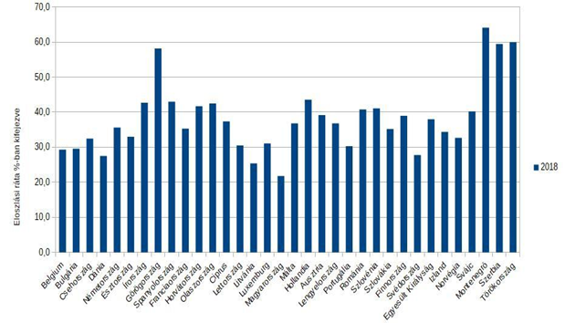

1. *Figure: Distribution of atypical forms of employment in individual countries*

*Source: Eurostat, 2020, online*